North West Tour Report

Over the last weekend Freddie, Josh and I competed in the North West Tour, a 3-day youth stage race that took place in Lancaster and the surrounding area. The tour opened with a short prologue on Morecambe promenade on the Saturday. The next day there was a long hilly stage that looked to be the most challenging, and, on the final day, the race went to the Salt Ayre circuit for stages 3 and 4.

Stage 1

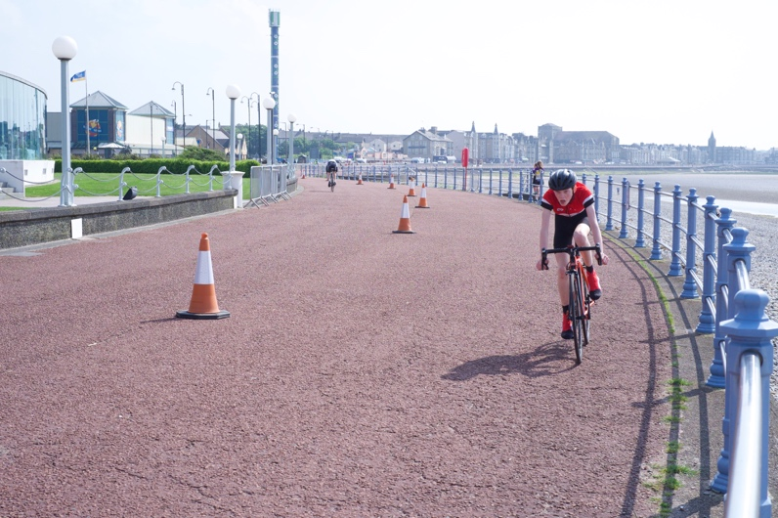
Stage 1 was a 2.4km prologue along the Morecambe promenade. It was an out and back course with a hairpin at the halfway point. Before the racing started all the riders rode the course and signed on, receiving their transponder and numbers that they had to use for the remainder of the tour. I was one of the first off for the U14 Boys and managed a time of 3:25. Freddie rolled in later with a time of 3:34. The winner of the stage had a time of 3:04 putting him in the leader’s jersey the next day. At the end of the day, my time held up for 32nd and Freddie’s for 54th.

Stage 1 Strava Stage 1 Results

Stage 2

Stage 2 was the hardest of the four stages, a closed road stage that took in 64m of elevation every 3.3km lap. Freddie had been having mechanical problems with his bike the previous day, so had to borrow my dad’s bike and lock off the gears. This inevitably held him back. The U14 boys race was 8.5 laps, and started at the bottom of the hill. In the beginning of the stage, I tried to get into the lead group as climbing is one of my strengths, but just missed catching onto the back as I couldn’t get past all of the riders on the road. I managed to find 2 other riders to work with but, as I reached the top of the hill, I found I couldn’t get into my big ring. In the end, I had to push it with my hand every lap. For the last lap, I knew I wouldn’t have the time to push the chain onto the big ring so I had to ride the last steep climb in my big ring, which tired me out for the final push to the line up a smaller hill. I just avoided being lapped by the lead riders and came 23rd leaving me 23rd on GC. Freddie had been in the largest group on the road, that had just been lapped, and rolled over the line in 55th leaving him 56th on GC.
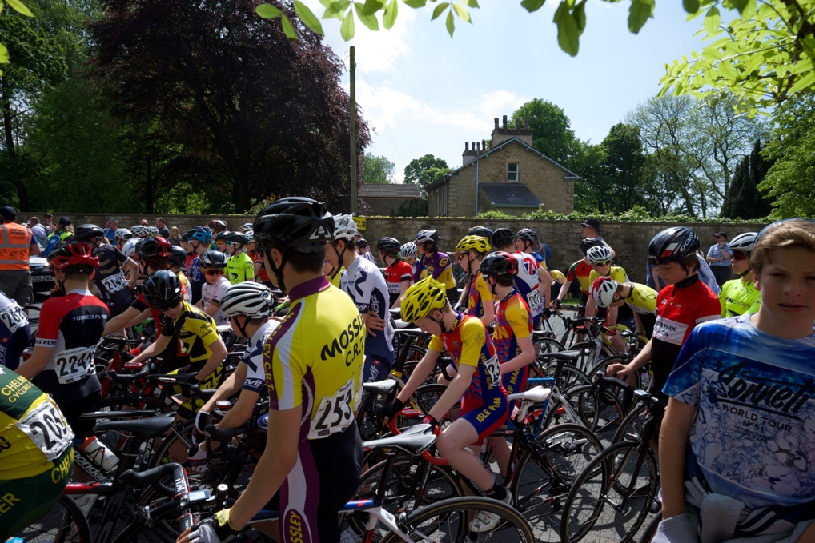

Stage 2 Strava Stage 2 Results

Stage 3

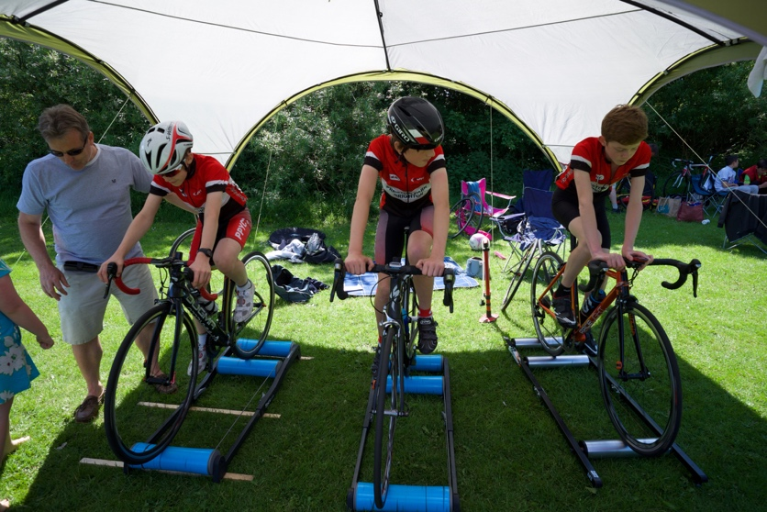
On the last day of the tour, the racing took part on the 1.27km Salt Ayre circuit. The circuit had grass on either side of it which would provide a launchpad for various attacks during the races. It was also a place that I got pushed onto during the race, nearly riding over some spectators! After 19km of racing the average speed was 42kph coming into the final half lap. As the bunch exited the final bend everyone accelerated and somebody crashed on the right hand side. I was on the left and thought I would just go past the crash but somebody’s bike flew across the circuit and I went over the handlebars, luckily landing on the grass. Around 20 other riders went down but the GC remained mostly unchanged as the crash was within the last 3km. I came off quite well compared to other riders, only bruising my knee and back.

Stage 3 Strava Stage 3 Results

Stage 4
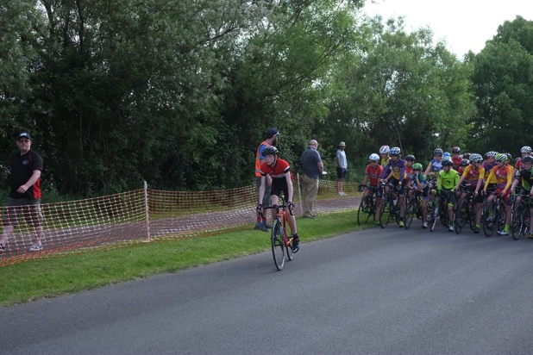
Stage 4 had to be shortened due to delays from crashes so, instead of racing the full 15 laps, we raced 13 laps. The variation on the morning’s stage was that we were racing the other way around the circuit. The pace was no different holding the average speed at about 42kph. At the bend after 3 laps to go, the whole bunch slowed down, and I had to move into a gap that wasn’t there. I crashed-half on to the grass- with the race leader. Freddie hadn’t crashed but someone’s bike had gone into his rear wheel resulting in some broken spokes. I carried on and eventually lost 1:10 and came 58th. This left me at 27th on GC. Freddie came 39th on GC.

Stage 4 Strava Stage 4 Results

