Preston Park Youth Cycling Club
Circuit Championships
Saturday 22nd October 2016

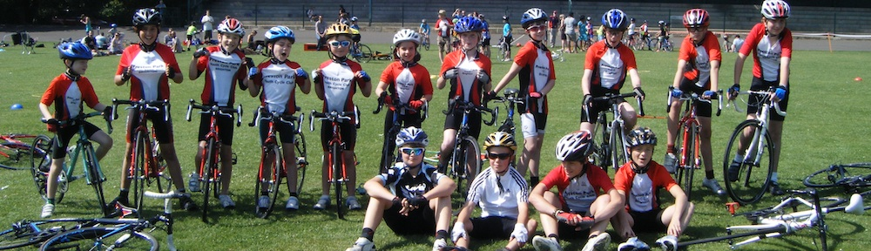

Welcome

Welcome to the PPYCC Circuit Championships which is also being run as Go-Racing event. The event is organised by PPYCC and taking place at Cyclopark, Gravesends, Kent. Within the many facilities at Cyclopark is located a purpose built road cycling circuit comprising of multiple smaller circuits, clubhouse and facilities and has a year round cycling and racing programme for all levels of cyclists.

We hope you have a great day and are looking forward to some exciting racing.

Event organizer

Paul Goodwill
Tel: 07851 815713
Email: goodwillpaul@hotmail.com

Location

The Tollgate
Wrotham Road
Gravesend
Kent
DA11 7NP
Call 01474 831 400

Getting There

http://www.cyclopark.com/plan-your-visit/how-to-get-here/

By Car : Cyclopark is located close to the A2 to the south of Gravesend, Kent. Take the A227 junction, (Gravesend Central) and follow the signs for Cyclopark. For Sat Nav please use post code DA11 7NP.

Facilities

The circuit facilities will open at 9:00 am on Saturday 22nd October.

Please ensure that you allow sufficient time prior to your race to park, register and warm up.

Keep your bikes(s) and all other equipment safe and secure at all times as the entire area, with the exception of the course itself, is open to both the general public and riders alike.

There are changing facilities in the clubhouse. There is hard standing both near the Clubhouse and at the start for using turbo trainers and rollers. Please do not block the walkways or access to the clubhouse or track when using turbo trainers or rollers.

There will catering available from the Cyclocafe . Please take your rubbish home with you or use the bins provided.

First aid provision

There will be first aid cover for the day by PPYCC coaches trained in First Aid.

In the unfortunate event of a rider needing to be taken to hospital,
the nearest A&E hospital is:

Darent Valley Hospital, Darent Wood Road, Dartford, Kent, DA2 8DA. Tel: 01322 428100 (switchboard)

Racing Schedule

Warm-up on the circuit will commence from 09:30am

Category Start time Duration

Cat D&E U8/U10 10:00 am 15 minutes
Cat C U12 10:20 am 20 minutes
Cat B U14 10:45 pm 25 minutes
Cat A U16 11:20 pm 30 minutes

Due to time available on the circuit all events will be mixed boys and girls. However, there will be separate starts in U14 & U16 with boys starting 10 seconds before the girls. There will be separate results for boys and girls in each age category.

Gear restrictions

All races are run under the rules and regulations of British Cycling. Please ensure that your gearing complies to the BC restrictions which
are there to protect riders and to make racing fairer for all. It is up to you to ensure that your bike gears are correct for your age category.
Youth A
U16 Cat A U14 Cat B U12 Cat C U10 Cat D U8 Cat E
6.93 metres 6.45 metres 6.05 metres 5.40 metres 5.10 metres

Before signing on please ensure your child bike is gear checked (outside the Clubhouse and you have a sticker on the licence.

If this is your childs first event and you’re unfamiliar with gear restrictions please contact us or discuss with coaches at training sessions who will be more than happy to provide advice.

Sign on

Sign-on is in the Clubhouse. Last sign-on for each age category is 30 minutes before the race. You will need to produce your valid 2016 BC racing licence – as youth members of British Cycling these are provided as part of your membership.

Race entry is entry on the day £5 per rider covering track hire and BC Go-Racing fees.

Numbers
At sign-on you will be provided with one number for your race along with safety pins in exchange for your racing licence. It is important that you position your number on the bottom right of your jersey so that it can be clearly seen by the race judges who will be recording your laps and finishing position. Please ensure you return all numbers at the completion of your race. On return of your race number your licence will be returned.

Safety
The circuit has been properly risk-assessed and we are confident that it is safe. This is also based on numerous senior and youth events that have taken place on the circuit. There are a number of corners that, with a bunch, may require extra vigilance. With this in mind, any rider who is
not confident in the bunch is respectfully reminded to stay out of trouble. We all need to be aware that ‘racing incidents’ can occur without fault. Each rider owes a duty of care to his or her fellow riders

Your race
Please be ready for your race 10 minutes before the start of your race. Do not ride on the circuit until confirmation has been received by the marshal that the circuit is clear and the marshal has deemed it safe to ride to the pit area. There will be no opportunity to warm up on the circuit between races.

Laps out
British Cycling regulations for laps out due to technical problems state:
“In a circuit race held on any circuit of less than 2 km a rider who punctures, crashes or suffers the breakage of an essential component will be permitted, except within the last five laps, to rejoin the race, after omitting one lap, in the same position as when the incident occurred,with the approval of the Chief Commissaire .”

Prizes

Presentations will take place by finish line.

Prize winners riders will be called to the podium to receive their medals.

There will be prizes for both Boys and Girls in all age categories.

Note this is a Go-Racing event and BC points are not on offer.

Thank you

A big thank you to the coaches, volunteers and members of the PPYCC supporting this event and the support from Cyclopark in the hosting of the event.

